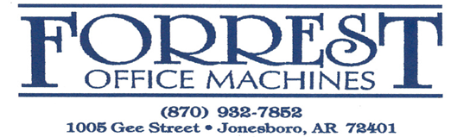
April 11, 2024
Dear Recipient:
Greetings! I'm Luke Richey, your dedicated sales representative at Forrest Office Machines. With a passion for innovation and a commitment to excellence, I specialize in providing top-of-the-line office solutions that drive efficiency, productivity, and growth for businesses of all sizes.
Why Choose Forrest Office Machines?
1. Comprehensive Product Portfolio: Forrest Office Machines offers a diverse range of cutting-edge office equipment and solutions tailored to meet the unique needs of your business. From advanced printers and copiers to state-of-the-art document management systems, we have everything you need to streamline your workflow and optimize your operations.
2. Expertise and Support: As your trusted partner, I bring years of industry experience and expertise to the table. Whether you're looking to upgrade your office equipment, optimize your print environment, or implement digital solutions, I will work closely with you to understand your requirements and recommend the best solutions to achieve your goals.
3. Exceptional Service: At Forrest Office Machines, we prioritize customer satisfaction above all else. From the initial consultation to post-sales support and maintenance, you can count on us to deliver exceptional service every step of the way. We are dedicated to ensuring that your investment continues to deliver value long into the future.
4. Cost-Effective Solutions: We understand the importance of staying within budget. That's why we offer cost-effective solutions that deliver maximum value without compromising on quality. With Forrest Office Machines, you can achieve your objectives without overspending.
Get in Touch Today!
Ready to take your office productivity to the next level? Contact me today to schedule a consultation and discover how Forrest Office Machines can help you unlock your full potential. Together, let's transform your workplace into a hub of innovation and efficiency. I look forward to the opportunity to work with you and contribute to your success!

Warm Regards,
Luke Richey
Forrest Office Machines B: 870-932-7852
1005 Gee Street Jonesboro, Arkansas 72401 C: 870-595-4876
Email:lukerichey.fom@gmail.com

